***Dt : 27/8/2022***

***Ex-Program-1 : DemoBlock1.java***

***class DemoBlock1 //MainClass***

***{***

***static int a = 10;//Static variable memory in class***

***static***

***{***

***System.out.println("====Static block====");***

***System.out.println("The value a:"+a);***

***}***

***public static void main(String[] args)***

***{***

***System.out.println("====main()=====");***

***System.out.println("The value a:"+a);***

***}***

***}***

***o/p:***

***====Static block====***

***The value a:10***

***====main()=====***

***The value a:10***

***==========================================================***

***Execution flow of above program:***

***ClassFiles:***

***DemoBlock1.java***

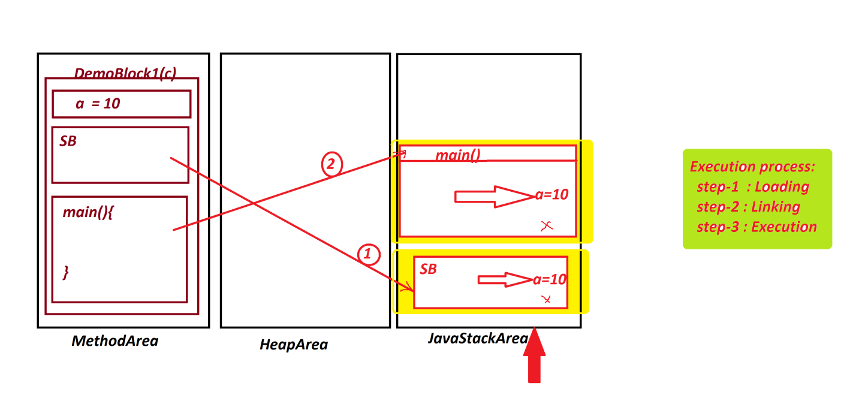

***=======================================================***

***Ex-Program-2 : DemoBlock2.java***

***class BTest1 //SubClass***

***{***

***static int b; //Static variable memory in Class***

***static***

***{***

***System.out.println("====SubClass Static block====");***

***System.out.println("The value b:"+b);***

***}***

***}***

***class DemoBlock2 //MainClass***

***{***

***public static void main(String[] args)***

***{***

***BTest1.b = 200;//Initializing value to variable b***

***//To Initialize value the class is used***

***System.out.println("====main()=====");***

***System.out.println("The value b:"+BTest1.b);***

***}***

***}***

***o/p:***

***====SubClass Static block====***

***The value b:0***

***====main()=====***

***The value b:200***

***================================================***

***Execution flow of above program:***

***ClassFiles:***

***BTest1.class***

***DemoBlock2.class(MainClass)***

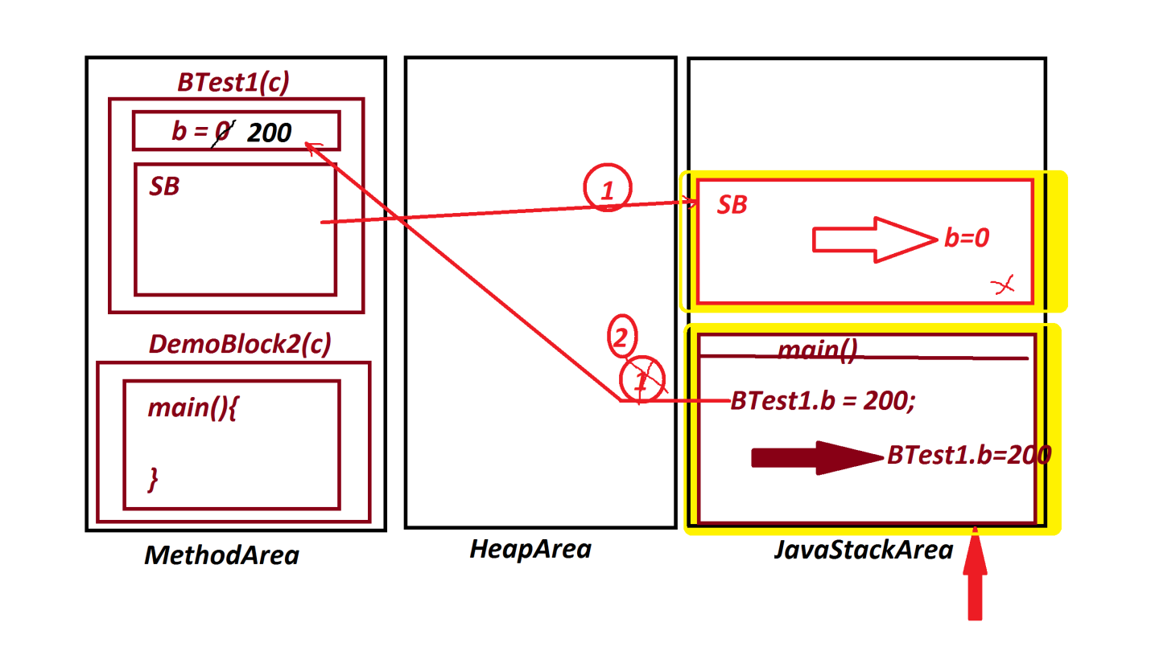

***==================================================***

***Note:***

***=>In realtime static block is used to hold DataBase connection***

***code in DAO(Data Access Object) layer of MVC***

***(Model View Controller).***

***===================================================***

***2.Non-Static blocks or Instance blocks:***

***=>The blocks which are declared without static keyword are***

***known as NonStatic blocks or Instance blocks.***

***syntax:***

***{***

***//set-of-statements;***

***}***

***behaviour:***

***=>Instance blocks are executed while object creation process.***

***=>Instance blocks are executed for all the multiple object***

***creations.***

***=>Instance blocks can access both static and Instance variables***

***directly.***

***Ex-Program-3 : DemoBlock3.java***

***class BTest2 //SubClass***

***{***

***int a=10;//Instance Variable memory in object***

***static int b=20;//Static Variable memory in Class***

***{***

***a++;***

***b++;***

***System.out.println("====SubClass Instance Block===");***

***System.out.println("The value a:"+a);***

***System.out.println("The value b:"+b);***

***}***

***}***

***class DemoBlock3 //MainClass***

***{***

***public static void main(String[] args)***

***{***

***System.out.println("****ob1*****");***

***BTest2 ob1 = new BTest2();***

***System.out.println("****ob2*****");***

***BTest2 ob2 = new BTest2();***

***}***

***}***

***o/p:***

***\*\*\*\*ob1\*\*\*\*\****

***====SubClass Instance Block===***

***The value a:11***

***The value b:21***

***\*\*\*\*ob2\*\*\*\*\****

***====SubClass Instance Block===***

***The value a:11***

***The value b:22***

***===============================================***

***Dt : 29/8/2022***

***Execution flow of above program:***

***ClassFiles:***

***BTest2.class***

***DemoBlock3.clas(MainClass)***

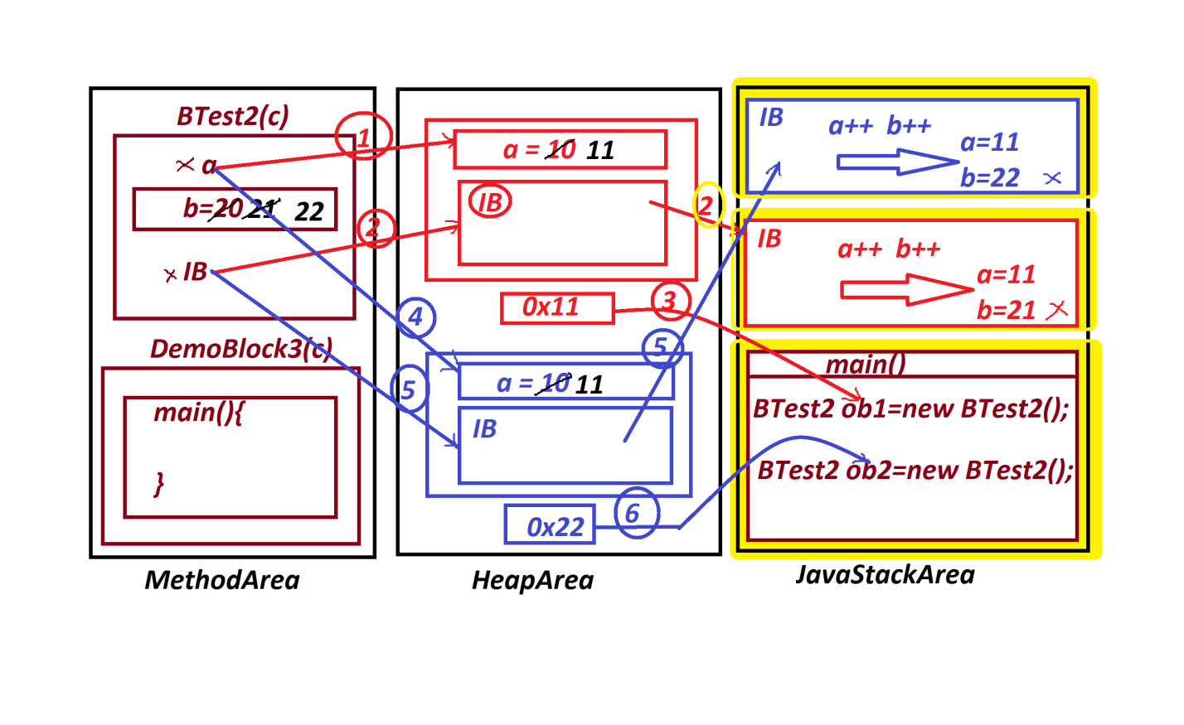

***=================================================***

***Note:***

***(i)Class can generate any number of objects and the Objects are***

***independent by their memory location on HeapArea.***

***(ii)Class loads only once for multiple Object creations.***

***===================================================***

***faq:***

***wt is the diff b/w***

***(i)Method***

***(ii)Block***

***=>Methods are executed on method_call,but blocks are executed***

***automatically without calling.***

***=>Blocks has highest priority in execution than methods.***

***=>Static blocks will have highest priority in execution than***

***Static methods***

***=>Instance blocks will have highest priority in execution than***

***Instance methods***

***=========================================================***

***faq:***

***can we construct program without main() method?***

***=>Yes,we can construct Java Programs without main() method***

***upto Java6 version,but not posible from Java7 version onwards.***

***===========================================================***

***\*imp***

***Constructors in Java:***

***=>Constructor is a method having the same name of the class and***

***executed while object creation,because the constructor call is***

***available in Object creation syntax attached with 'new' keyword.***

***Note:***

***=>while declaring constructors we must not use return_type***

***because constructors will have Class_return_type.***

***structure of Constructor:***

***Class_name(para_list)***

***{***

***//Constructor_body***

***}***

***=>Constructors in Java are categorized into two types:***

***1.Constructors without parameters***

***2.Constructors with parameters***

***1.Constructors without parameters:***

***=>The constructors which are declared without parameters are***

***known as 0-parameter Constructors or Constructors without***

***parameters.***

***Ex-program : DemoCon1.java***

***class CTest1 //SubClass***

***{***

***int a=10;//Instance variable memory in object***

***CTest1()//Constructor***

***{***

***System.out.println("====Constructor CTest()====");***

***System.out.println("The value a:"+a);***

***}***

***void dis()//Instance method***

***{***

***System.out.println("====Instance dis()====");***

***System.out.println("The value a:"+a);***

***}***

***}***

***class DemoCon1 //MainClass***

***{***

***public static void main(String[] args)***

***{***

***CTest1 ob = new CTest1();//Con_call***

***ob.dis();//method_call***

***ob.dis();***

***ob.dis();***

***}***

***}***

***o/p:***

***====Constructor CTest()====***

***The value a:10***

***====Instance dis()====***

***The value a:10***

***======================================================***

***Execution flow of above program:***

***ClassFiles:***

***CTest1.class***

***DemoCon1.class(MainClass)***

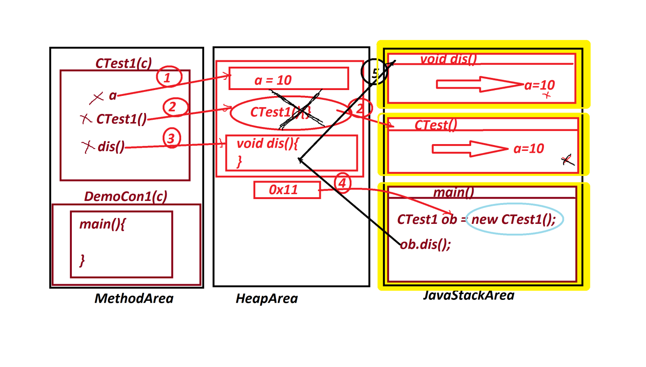

***========================================================***

***faq:***

***wt is the diff b/w***

***(i)Constructor***

***(ii)Instance methods***

***=>Constructor is executed while object creation,but Instance***

***method is executed after Object creation.***

***=>Constructor executed only once while object creation,but***

***Instance method can be executed any number of times from the***

***same object.***

***=======================================================***

***faq:***

***define Destructors in Java?***

***=>There is no concept of destructors in java,because the***

***constructors destroyed automatically after execution.***

***======================================================***